Time Series Analysis

Here we use AR(2) model since we didn’t see obvious clustering property after plotting all the parameters. Followings are the plots of parameters of each model against time and the corresponding AR models.

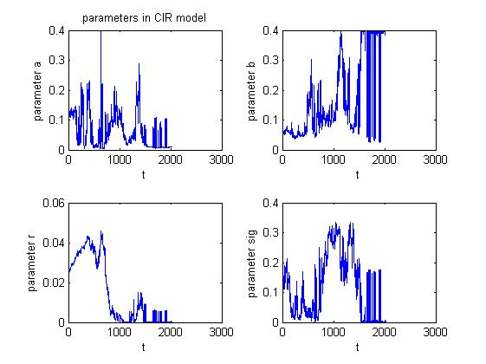

AR(2) model to CIR model parameters, , in form of 0=a_0 X(t)+a_1 X(t-dt)+a_2 X(t-2dt)-e.

|  |  |  |  |
| --- | --- | --- | --- |
|  | a_0 | a_1 | a_2 |
| a | 1 | -0.81406 | -0.15638 |
| b | 1 | -0.62314 | -0.35448 |
| r | 1 | -0.61422 | -0.38458 |
| sig | 1 | -0.67808 | -0.30941 |

From the chart above we can see that the AR(2) model of the coefficients are stationary and will converge to its expectation.

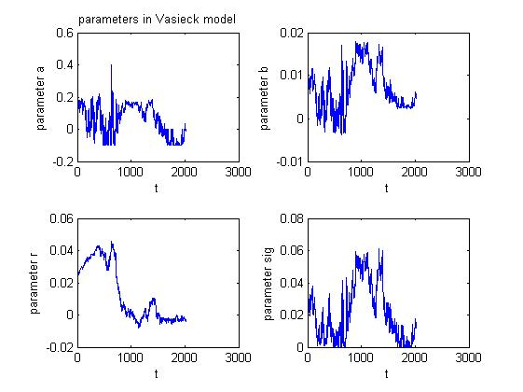

AR(2) model to Vasicek model parameters, , in form of 0=a_0 X(t)+a_1 X(t-dt)+a_2 X(t-2dt)-e.

|  |  |  |  |
| --- | --- | --- | --- |
|  | a_0 | a_1 | a_2 |
| a | 1 | -0.74949 | -0.22706 |
| b | 1 | -0.79185 | -0.20073 |
| r | 1 | -0.97559 | -0.02405 |
| sig | 1 | -0.8804 | -0.11584 |

From the chart above we can see that the AR(2) model of the coefficients are stationary and will converge to its expectation.

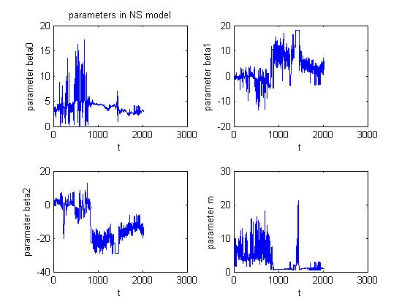

AR(2) model to NS model parameters, , in form of 0=a_0 X(t)+a_1 X(t-dt)+a_2 X(t-2dt)-e.

|  |  |  |  |
| --- | --- | --- | --- |
|  | a_0 | a_1 | a_2 |
| beta_0 | 1 | -0.72244 | -0.2408 |
| beta_1 | 1 | -0.62498 | -0.33177 |
| beta_2 | 1 | -0.61689 | -0.37307 |
| m | 1 | -0.69684 | -0.24619 |

From the chart above we can see that the AR(2) model of the coefficients are stationary and will converge to its expectation.